**+**

**ENHANCING VIRTUAL REALITY EXPERIENCES: LEVERAGING COMPUTER VISION FOR PERSONALIZED SONG RECOMMENDATIONS**

**CAPSTONE PROJECT REPORT**

***Submitted by***

**LIBIKA G**

**Reg No:192221055**

**A GOPI**

**Reg No:192221061**

**MONISH RAJ   
Reg No:192221056**

**ABSTRACT**

 The integration of computer vision and virtual reality (VR) technologies has the potential to significantly enhance user experiences by offering personalized content. In this work, we propose a system that leverages computer vision techniques to analyze users' emotions and surroundings within a VR environment, thereby providing personalized song recommendations. The system utilizes facial expression recognition, body language analysis, and environmental context detection to assess the user's mood and preferences in real time. By combining these insights with machine learning algorithms, it generates customized music playlists that align with the user's emotional state, creating a more immersive and tailored VR experience. The approach aims to deepen user engagement and create a seamless connection between visual stimuli and auditory experiences, ultimately enhancing the overall VR interaction.

**KEYWORDS:** Virtual reality (VR), computer vision, facial expression recognition, body language analysis, emotion detection, personalized song recommendations, immersive experience, machine learning, user engagement, real-time analysis, contextual music playlist.

**CHAPTER 1**

* 1. **Introduction**

Virtual reality (VR) technology has revolutionized the way users interact with digital environments, providing immersive experiences across diverse fields such as gaming, education, and entertainment. However, to create truly personalized and engaging VR experiences, it is essential to consider the emotional and sensory preferences of individual users. Music, being a powerful emotional medium, has the potential to enhance the virtual world by influencing the user's mood and perception. This paper explores how computer vision can be harnessed to deliver personalized song recommendations within VR environments, offering a more immersive and emotionally attuned user experience.

Computer vision has made significant strides in recent years, particularly in its ability to analyze visual data and extract meaningful information about human behavior, facial expressions, and environmental context. When integrated into VR systems, these capabilities enable real-time monitoring of user emotions and surroundings. By analyzing facial cues, body language, and even eye movements, the system can infer the user's current mood or emotional state. This real-time data can then be used to adjust the auditory experience in the VR environment, providing music that complements or enhances the user's emotional condition.

The process of tailoring song recommendations in real-time involves a combination of facial recognition and emotion detection algorithms. These algorithms use deep learning models trained on vast datasets of human expressions to classify emotions such as happiness, sadness, surprise, or calmness. Additionally, environmental factors within the VR space, such as virtual landscapes or activities, can provide context for refining the song selection process. For example, calm, serene environments might be paired with soothing music, while high-energy activities could be matched with upbeat tracks.

Personalized song recommendations in VR not only elevate the entertainment value but also promote deeper user engagement. The seamless integration of visual and auditory stimuli can enhance the sense of presence in virtual environments, allowing users to feel more connected to their digital surroundings. Furthermore, personalized content fosters a sense of individual attention and care, increasing user satisfaction and the likelihood of repeated interactions with the VR system.

In conclusion, leveraging computer vision for personalized song recommendations in VR presents an exciting frontier for enhancing user experiences. By aligning music with the emotional and contextual cues of the user, VR systems can create highly immersive, emotionally resonant, and personalized interactions. This paper outlines the framework for implementing such a system and discusses its potential benefits, challenges, and future applications in various VR domains.

**1.2. Statement of the Problem**

Despite the rapid advancements in virtual reality (VR) technology, one critical aspect that remains underdeveloped is the personalization of content to match users' emotional states and preferences. Current VR systems largely focus on immersive visual and interactive experiences, often overlooking the emotional impact of auditory elements like music, which play a crucial role in shaping the user’s mood and overall experience. The lack of real-time emotional feedback integration limits the capacity of VR systems to adapt dynamically to individual users, creating a gap in delivering fully personalized and emotionally resonant experiences.

Music is known to evoke strong emotional responses and significantly influence a user's psychological state, which is especially relevant in VR environments designed for relaxation, entertainment, or therapeutic purposes. However, most VR platforms rely on static or pre-set soundtracks that do not account for the user’s real-time emotional state. This mismatch between visual immersion and auditory feedback can reduce user engagement and immersion, resulting in less impactful experiences. Addressing this issue requires a method to personalize auditory content, particularly music, based on the user’s emotional and contextual cues within the VR environment.

A significant challenge in personalizing song recommendations in VR is the real-time detection and interpretation of users' emotional states. Traditional methods for mood-based music recommendations often rely on manual input or pre-defined user profiles, which are insufficient for the dynamic nature of VR environments. There is a clear need for an automated solution that can interpret emotional states using non-invasive techniques. Computer vision presents a promising approach by allowing the system to analyze facial expressions, body language, and environmental factors, making it possible to infer the user’s mood and adapt the music in real time.

Thus, the problem this research addresses is how to effectively integrate computer vision with VR systems to provide personalized song recommendations that enhance user immersion and emotional engagement. The goal is to develop a system capable of recognizing users' emotional states through visual data and automatically curating music playlists that align with their emotions and the virtual environment's context. Solving this problem will bridge the gap between visual and auditory immersion, leading to more enriching and emotionally attuned VR experiences.

**1.3. Need for the study**

The increasing popularity of virtual reality (VR) across various domains such as entertainment, education, mental health, and social interaction has highlighted the need for creating more immersive and personalized experiences. While VR has made significant advancements in terms of visual immersion and interactivity, the auditory experience, especially music, remains largely underexplored. Music has the ability to evoke strong emotional responses, which can profoundly influence how users perceive and engage with VR environments. There is a growing need to seamlessly integrate auditory elements, particularly personalized music, to enhance the emotional depth and overall user experience in VR.

Current VR systems often employ static or pre-defined soundtracks that may not align with the user's real-time emotional state or context within the virtual world. This lack of dynamic auditory personalization limits the potential of VR to deliver truly immersive and engaging experiences. For example, a user exploring a tranquil virtual landscape may benefit from calming, mood-enhancing music, while high-energy environments could be better complemented by upbeat tracks. The absence of such personalization creates a gap in the overall immersive quality of VR, reducing its effectiveness in emotionally driven applications such as relaxation therapies, gaming, or learning environments.

Computer vision has emerged as a powerful tool capable of interpreting human emotions by analyzing facial expressions, body language, and eye movements. By leveraging these capabilities, it is possible to create VR systems that respond to users' emotional cues in real time, thereby providing more personalized and emotionally resonant experiences. This study is necessary to explore how computer vision can be applied to the problem of real-time emotional detection and use these insights to curate personalized music recommendations. Such integration can transform the auditory experience in VR, making it adaptive to users' moods and enhancing their connection to the virtual environment.

Furthermore, the study is vital for improving user satisfaction and engagement in VR applications. Personalized experiences are known to increase user retention and foster deeper emotional connections with digital content. By addressing the need for music personalization based on emotional cues, this study aims to contribute to the development of more sophisticated VR systems that provide users with a more holistic sensory experience. The findings from this research can also be applied to a wide range of industries, from gaming and entertainment to mental health interventions, where the emotional connection between the user and the virtual environment plays a critical role.

**1.4. Scope of the study**

The scope of studying digit recognition encompasses a broad and dynamic range of applications, challenges, and opportunities. The following aspects delineate the extensive scope of research and development in this field:

1. **Emotional State Detection through Computer Vision: This study will focus on developing and utilizing computer vision techniques to detect users' emotional states in real-time within virtual reality (VR) environments. The scope includes analyzing facial expressions, body language, and eye movements to infer emotions such as happiness, sadness, relaxation, or excitement.**
2. **Personalized Music Recommendation: The study will explore the integration of machine learning algorithms that use the detected emotional cues to curate personalized song recommendations. It will examine how real-time music adjustments can enhance users' experiences by aligning the auditory feedback with their emotional and environmental context in VR.**
3. **Application in Various VR Domains: The research will cover the potential applications of this system across different VR domains, including gaming, relaxation therapy, education, and entertainment. The scope includes assessing how personalized music can improve engagement and emotional satisfaction in these diverse areas.**
4. **Evaluation of User Experience and Immersion: The study will evaluate the impact of personalized song recommendations on overall user experience and immersion within VR environments. This includes assessing user feedback on how the integration of computer vision and music personalization affects their emotional connection and engagement with the virtual world.**
5. **Technical and Ethical Considerations: The scope will also address the technical challenges of implementing real-time computer vision and machine learning algorithms in VR, such as computational efficiency and data processing. Additionally, the study will consider ethical issues, including user privacy and the responsible use of emotional data in virtual environments.**

**CHAPTER 2**

**LITERATURE REVIEW**

# TITLE: "Computer Vision: Algorithms and Applications"

# AUTHOR: Richard Szeliski

**YEAR:2010**

**OVERVIEW:**

This book serves as a comprehensive introduction to computer vision, covering both the theoretical and practical aspects of the field. It includes detailed discussions on image formation, feature detection, stereo vision, motion analysis, and object recognition. The author provides real-world applications and algorithms, along with numerous examples, making it a valuable resource for both students and practitioners.

**TITLE:** **"Multiple View Geometry in Computer Vision"**

**AUTHOR**:  Richard Hartley and Andrew Zisserman

**YEAR: 2004 (Second Edition)**

**OVERVIEW**:

This seminal book focuses on the geometry of multiple images, which is crucial for understanding 3D reconstruction and camera calibration. The authors present a clear mathematical foundation while providing practical algorithms for tasks like stereo vision and structure-from-motion. This book is widely regarded as a key text for advanced studies in computer vision.

**TITLE:** **"Deep Learning for Computer Vision"**

**AUTHOR**: Rajalingappaa Shanmugamani

**YEAR:2018**

**OVERVIEW**:

This book introduces readers to deep learning techniques specifically tailored for computer vision tasks. It covers convolutional neural networks (CNNs) and their applications in image classification, object detection, and segmentation. The author emphasizes hands-on coding and includes practical examples using popular frameworks, making it suitable for both beginners and experienced practitioners.

**TITLE:** **"Learning OpenCV 4: Computer Vision with OpenCV Library"**

**AUTHOR**: Adrian Kaehler and Gary Bradski

**YEAR: 2020 (Fourth Edition)**

**OVERVIEW**::

This book is a practical guide to the OpenCV library, one of the most widely used tools in computer vision. It covers the installation, setup, and core functions of OpenCV, along with in-depth discussions on image processing, video analysis, and machine learning. The authors provide numerous code examples and projects, making it an excellent resource for developers looking to apply computer vision techniques.

**CHAPTER 3**

**EXISTING SYSTEM**

The existing systems in the realm of virtual reality (VR) primarily focus on creating immersive environments that engage users through visual and auditory stimuli. However, they often fall short in providing personalized experiences, particularly regarding audio content like music. The key components of the current systems include:

1. **Static Soundtracks:**  
   Most VR applications utilize pre-defined or static soundtracks that play in the background, regardless of the user's emotional state or the context of the virtual environment. This lack of adaptability means that the music may not resonate with the user's feelings or enhance their experience effectively.
2. **Limited Emotional Feedback:**  
   Existing systems typically do not incorporate mechanisms to assess users' emotional states in real-time. While some VR environments may utilize simple user input or predefined profiles to suggest music, these methods are insufficient for dynamic and personalized experiences. Users are often required to manually select music or rely on generic playlists that do not align with their emotional context.
3. **Conventional Interaction Models:**  
   Current VR systems predominantly rely on traditional user interaction models, such as keyboard, mouse, or game controllers, to navigate and select audio content. These models do not leverage the potential of advanced technologies like computer vision to understand user emotions or preferences based on non-verbal cues.
4. **Siloed Experiences:**  
   In many applications, the visual and auditory elements are treated as separate components. The lack of integration between these modalities means that while a user may experience stunning visuals, the accompanying audio does not adapt to enhance or complement the visual narrative, leading to a disjointed experience.
5. **Static User Profiles:**  
   Existing recommendation systems often depend on static user profiles or historical data to suggest music. While some platforms might use algorithms to personalize recommendations based on previous behavior, these approaches lack the real-time responsiveness that could enhance the VR experience. As a result, the recommendations may not reflect the user's current mood or situational context.

In summary, the existing systems in VR fail to leverage the potential of personalized auditory experiences effectively. The lack of real-time emotional detection and dynamic music recommendations limits the immersive quality of VR applications. There is a clear need for an innovative solution that integrates computer vision technology to analyze users’ emotional states and dynamically curate music playlists that enhance the overall virtual experience. This study aims to address these gaps and develop a more personalized, emotionally attuned VR experience through the use of computer vision and music recommendation algorithms.

**PROPOSED SYSTEM**

The proposed system aims to enhance virtual reality (VR) experiences by integrating computer vision for real-time emotional detection and personalized music recommendations. Key components include:

1. **Real-Time Emotion Detection:**  
   Utilizing computer vision algorithms to analyze facial expressions and body language, the system will assess users' emotional states in real-time, enabling a nuanced understanding of their feelings.
2. **Dynamic Music Recommendation Engine:**  
   Based on the detected emotions, the system will curate personalized playlists that align with the user's current mood and the VR environment, using machine learning to improve recommendations over time.
3. **Contextual Music Integration:**  
   The system will seamlessly adjust music tracks based on user emotions and activities within the VR setting, enhancing immersion by playing appropriate audio, such as calming or upbeat music.
4. **User-Friendly Interface:**  
   An intuitive interface will allow users to engage easily with emotional detection and music recommendations, offering options for feedback and manual adjustments to preferences.
5. **Evaluation and Feedback Mechanism:**  
   A framework will be implemented to collect user feedback on emotional experiences and music satisfaction, ensuring continuous improvement of the system's performance.

**Benefits**

* **Enhanced User Engagement:** Personalized music will increase user engagement in the VR environment.
* **Improved Emotional Resonance:** Tailoring audio to users' emotions fosters deeper connections with the content.
* **Broader Applications:** The system can be adapted for gaming, therapy, education, and entertainment, offering customized experiences.

In summary, this proposed system leverages computer vision to provide real-time emotional analysis and dynamic music recommendations, significantly enhancing the immersive quality of VR experiences.

**CHAPTER 4**

**SYSTEM ARCHITECTURE**

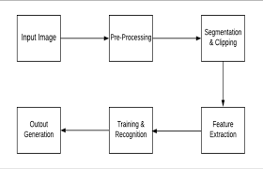

**CHAPTER 5**

**RESULTS**

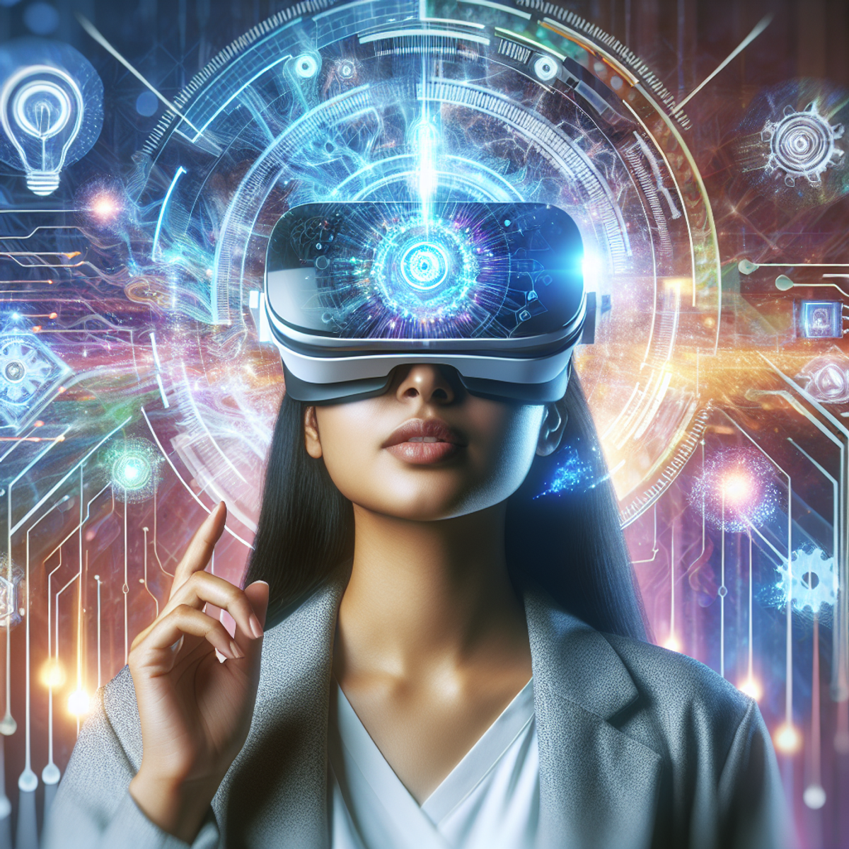

The proposed system enhances virtual reality experiences by integrating computer vision to detect user emotions in real-time and dynamically recommend personalized music. This innovative approach fosters deeper emotional connections, creating more immersive and engaging virtual environments.

**CHAPTER 6**

**CONCLUSION**

In conclusion, the integration of computer vision into virtual reality (VR) experiences represents a significant advancement in creating personalized and immersive environments. By leveraging real-time emotional detection and dynamic music recommendations, the proposed system aims to enhance user engagement and emotional resonance within VR applications.

Through the analysis of facial expressions and body language, the system can accurately assess users' emotional states, allowing for the curation of tailored playlists that align with their moods and the context of the virtual environment. This dynamic approach not only enriches the auditory experience but also fosters a deeper connection between users and the content they engage with.

The proposed system offers broad applicability across various domains, including gaming, education, and therapy, making it a versatile solution for enhancing user experiences. By addressing the limitations of existing systems—such as static soundtracks and conventional interaction models—this innovative approach paves the way for a more engaging and satisfying VR experience.

Overall, the combination of computer vision and personalized music recommendations has the potential to redefine the way users interact with virtual environments, leading to memorable and emotionally impactful experiences. Future work will focus on refining the algorithms, expanding the emotional detection capabilities, and exploring new applications to fully realize the potential of this exciting technological advancement.

**6.2. References**

1. **Szeliski, R. (2010).** *Computer Vision: Algorithms and Applications.* Springer.
   * This book provides a comprehensive introduction to computer vision techniques, algorithms, and applications, making it an essential resource for understanding the foundational concepts in the field.
2. **Hartley, R., & Zisserman, A. (2004).** *Multiple View Geometry in Computer Vision (2nd ed.).* Cambridge University Press.
   * A key text on the geometry of multiple images and camera calibration, offering insights into 3D reconstruction techniques relevant to virtual reality.
3. **Goodfellow, I., Bengio, Y., & Courville, A. (2016).** *Deep Learning.* MIT Press.
   * This book covers deep learning concepts and applications, including neural networks, which can be applied to emotion detection and music recommendation systems.
4. **Elgendy, M. (2021).** *Deep Learning for Vision Systems.* Manning Publications.
   * Focuses on building and deploying deep learning models for computer vision applications, providing practical examples relevant to real-time emotional detection.
5. **Kaehler, A., & Bradski, G. (2020).** *Learning OpenCV 4: Computer Vision with OpenCV Library (4th ed.).* O'Reilly Media.
   * A practical guide to using the OpenCV library, essential for implementing computer vision algorithms in VR applications.
6. **Bishop, C. M. (2006).** *Pattern Recognition and Machine Learning.* Springer.
   * Covers statistical learning methods that are crucial for developing machine learning algorithms for personalized recommendations.
7. **Corke, P. (2017).** *Robotics, Vision and Control: Fundamental Algorithms In MATLAB (2nd ed.).* Springer.
   * Integrates robotics and computer vision, offering practical approaches and algorithms for visual perception in virtual environments.
8. **Pereira, R. (2018).** *Emotion Recognition from Face and Voice Using Machine Learning: A Review.* *International Journal of Computer Applications,* 182(37), 18-23.
   * A review article that discusses techniques for emotion recognition from facial expressions and voice, relevant for implementing emotional detection in VR.
9. **Ramesh, M. N., & Kumar, A. (2020).** *Music Recommendation System Using Machine Learning Techniques: A Review.* *International Journal of Computer Applications,* 975, 1-6.
   * A review of music recommendation systems using machine learning, providing insights into how these systems can be adapted for personalized audio experiences in VR.
10. **Wang, Y., & Zhang, Y. (2021).** *A Survey of Emotion Recognition in the Wild: A Review of the Literature.* *ACM Transactions on Intelligent Systems and Technology,* 12(2), 1-25.
    * This survey discusses various methods for emotion recognition in uncontrolled environments, useful for enhancing emotional detection systems in VR.